Title: J-Curve and passthrough
Subject: MACRO 6

ΔE => CA
Volume effect: more quantity sold after depreciation
Value effect: lower price for each unit sold

J-Curve: In the Sr value effect prevails, in the Lr Volume effect.

i. Orders are set in 3-6 months advance
ii. Producers of exports may have to install additional plant and equipment and hire new workers
iii. If imports consist of intermediate products used in domestic manufacturing, import volumes will take time to fall as importers switch to new production techniques that economize on intermediate inputs which have become more expensive because of the depreciation.

Up to now we have assumed fixed prices ΔE => ΔRER. Hence up to now if E depreciated by 10% => RER depreciated by 10%. So if E$↑$ by 10% => import prices EP* $↑$ by 10%.
pass-through from exchange rate to import prices = The % by which import prices EP* rise when the home currency depreciates by 1%
With fixed prices Passtrhough is 1. In reality, there are several reasons why relative prices might not stay fixed. Some considerations (That weaken the j-curve):

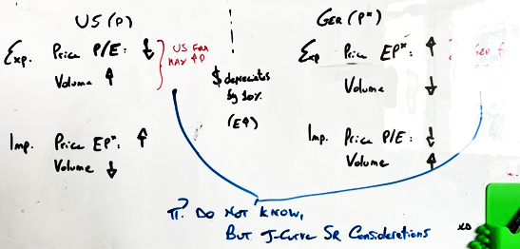
A. Firms Adjust Prices
1. Firms can adjust prices after appreciation/depreciation to gain mkt share or increase profits:
Ex. Dollar depreciates by 10%. With complete pass- through (i.e., if it did not change the euro price of its cars), BMW should maintain the euro price of its car => dollar price of cars EP* sold in the Us + 10%. But, maybe, in order not to lose mkt share it will cut prices by 4% st dEP = +6%. In an appreciation you could increase you prices to raise profits

B. Domestic price response:
2. In highly inflationary economies, if you change the nominal E the change quickly sparks domestic inflation, which in turn raises P: the relative price EP*/P does not change (due to: increased aggregate demand from abroad, expectations of lose mp from speculators, increase in intermediate inputs)
To the extent that a country’s prices in domestic currency rise when its currency depreciates, any favorable effect on its competitive position in world markets will be dissipated. This is effectively equivalent an incomplete pass- through. LOOK AT THE IMAGE ABOVE! JUST LIKE IF US IMMEDIATELY RAISE EXP PRICES! = NO BOOST

C. One key determinant of the pass-through is the currency in which internationally traded goods are invoiced: currently world trade in mainly invoiced in dollars

Key: Invoice prices in dollars are sticky up to a two-yr horizon (not updated) => This fact implies an asymmetry between short-run exchange rate pass- through for invoice currency countries and others <= Incomplete passthrough for invoice currency. The problem is not the fact prices are in dollars, rather that they are sticky when in dollars (Gita Gopinath)!

US imports are in dollars (90%) :
- if dollar depreciates there is no effect on import prices (tshirt = 30).

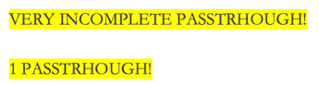
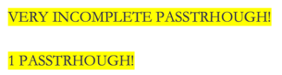
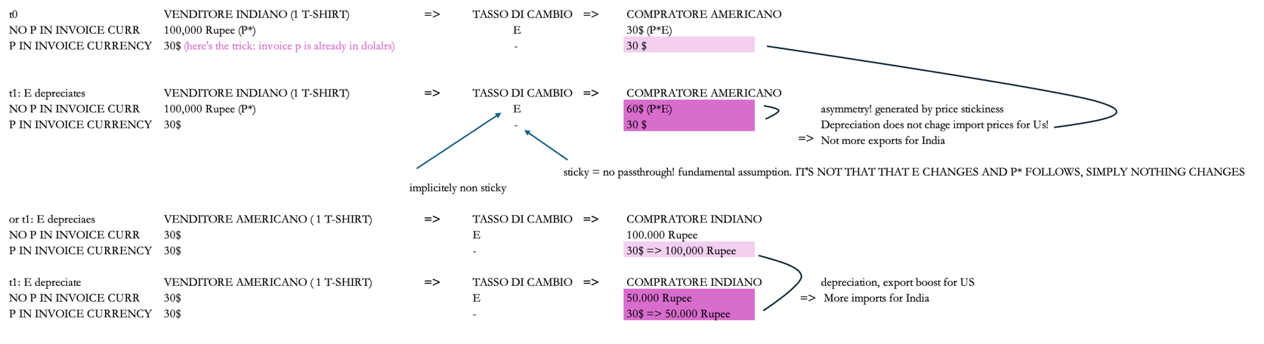
Jap imports are in dollars (71%) even if imports from us are 13%!
- if dollar depreciates impoers are less exprensive = import volume up
MAIN CHANNEL JAP

US Exports are in dollars (90%) :
- if dollar depreciates esports increase = volumes up = MAIN CHANNEL US
JAP exports are in dolalrs (tshirt = 30):
- if dollar depreciates exports do not change = reveneus in dollars do not change, but reveeus in Yen yes (profits) decrease

because these prices are quite sticky when measured in dollars, a dollar depreciation has little effect on the import prices U.S. consumers and firms face (EP*), but the immediate pass-through to foreign importers of U.S. goods, in terms of their own currencies (i.e. P/E), is close to 1 => a dollar depreciation may boost U.S. exports immediately but have little impact on the volume of U.S. imports

3. Global value Chain: Effects on exchange rates, imports and exports
Much of international trade takes the form of intermediate products. Countries produce just portions of the value added in a final product:
- backward linkages: imports account for 20% of value of total exports. Exchange rate depreciates => higher demand for exports (E) BUT price in domestic currency of the intermediate imports increase (P) => this will increase the price of its final products (PE) => muted effect of the depreciation on lowering the export prices.
- forward linkages: a country’s exports may go on to be incorporated as intermediate inputs

=> globalization linkages make CA effects smaller, but globalization also increased trade volumes => may offset

